**Airline Management System**



Session: 2020 – 2024

**Submitted by:**

Muhammad Umer Amjad 2020-CS-61

**Supervised by:**

Ms. Maidha Shahid

Department of Computer Science

**University of Engineering and Technology**

**Lahore Pakistan**

Table of Contents

**Class Diagram:** 3

**Sequence Diagram:** 4

**Wire Frame:** 5

**Code Of Classes:** 12

**AddAirLineBL:** 12

**AddFlightBL:** 12

**LoginBL:** 13

**PassengerBL:** 13

**PersonBL:** 14

AddAirLineDL: 15

**AddFlightDL;** 16

**LoginDL:** 18

**PassengerDL:** 20

# **Class Diagram:**

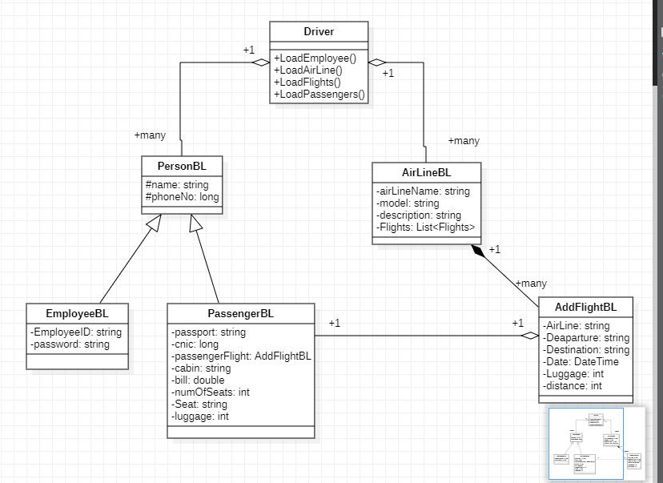

# **Sequence Diagram:**

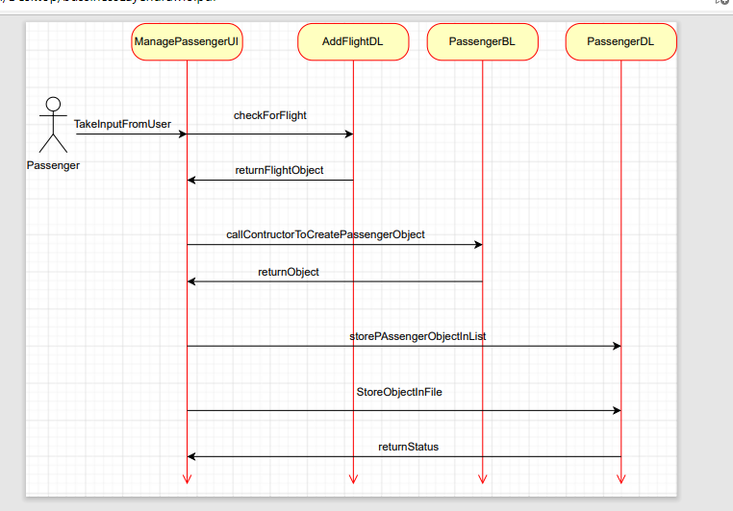

# **Wire Frame:**

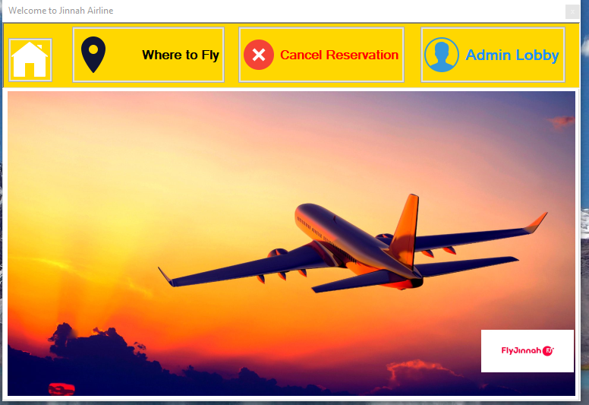

**Figure 1 Home Page**

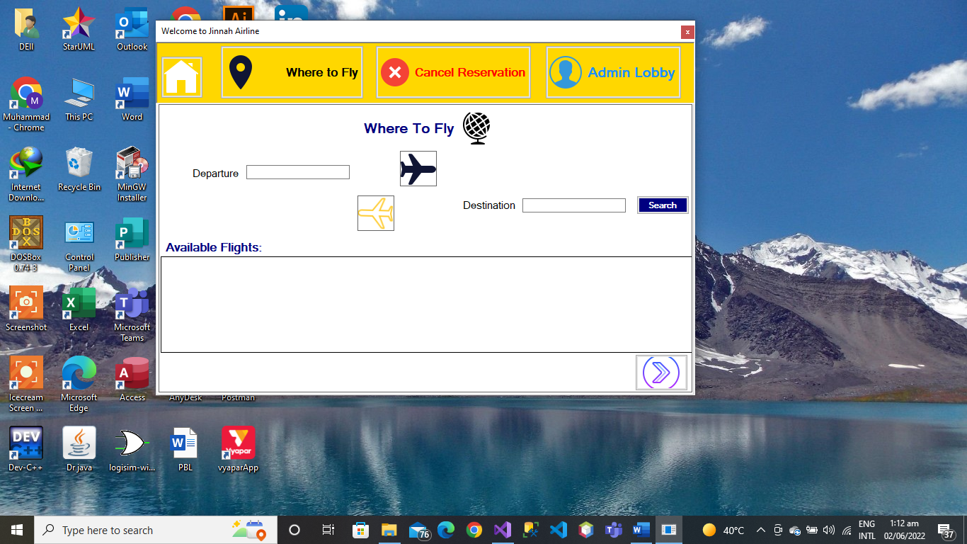

**Figure 2 Where to Fly**

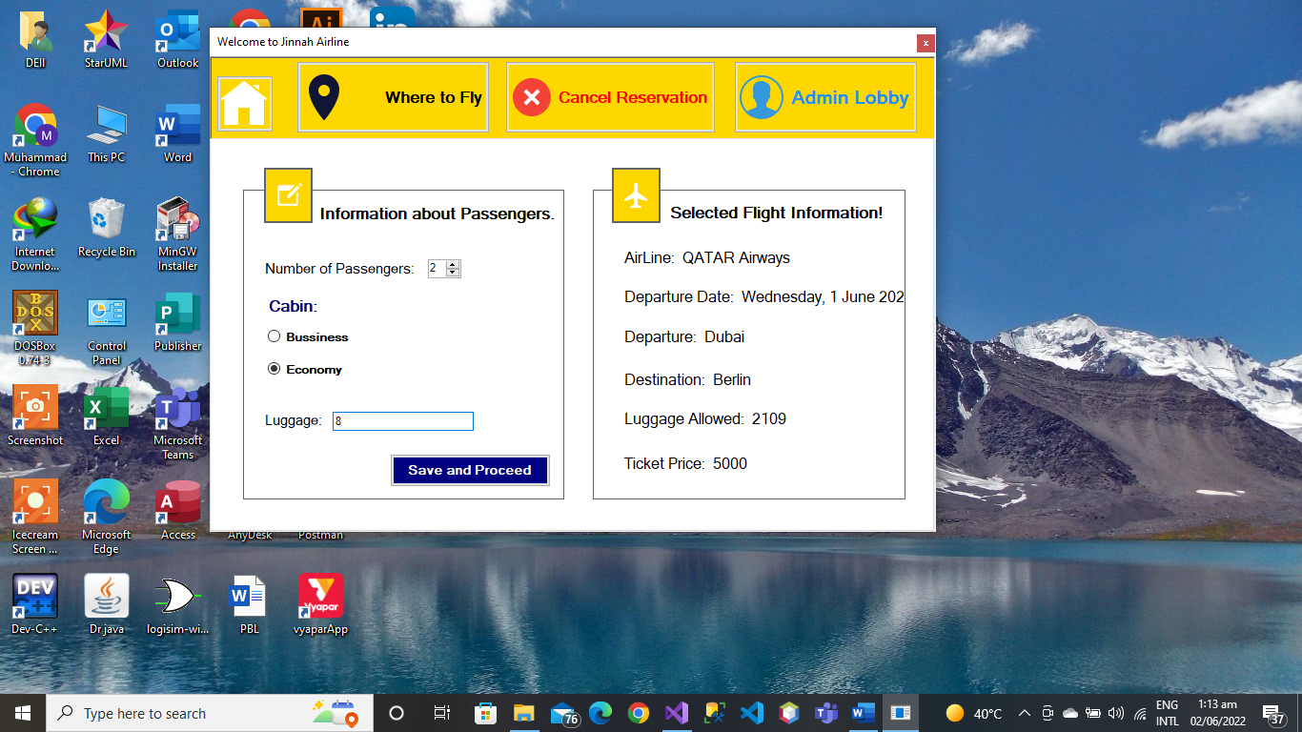

**Figure 3 Seat Information**

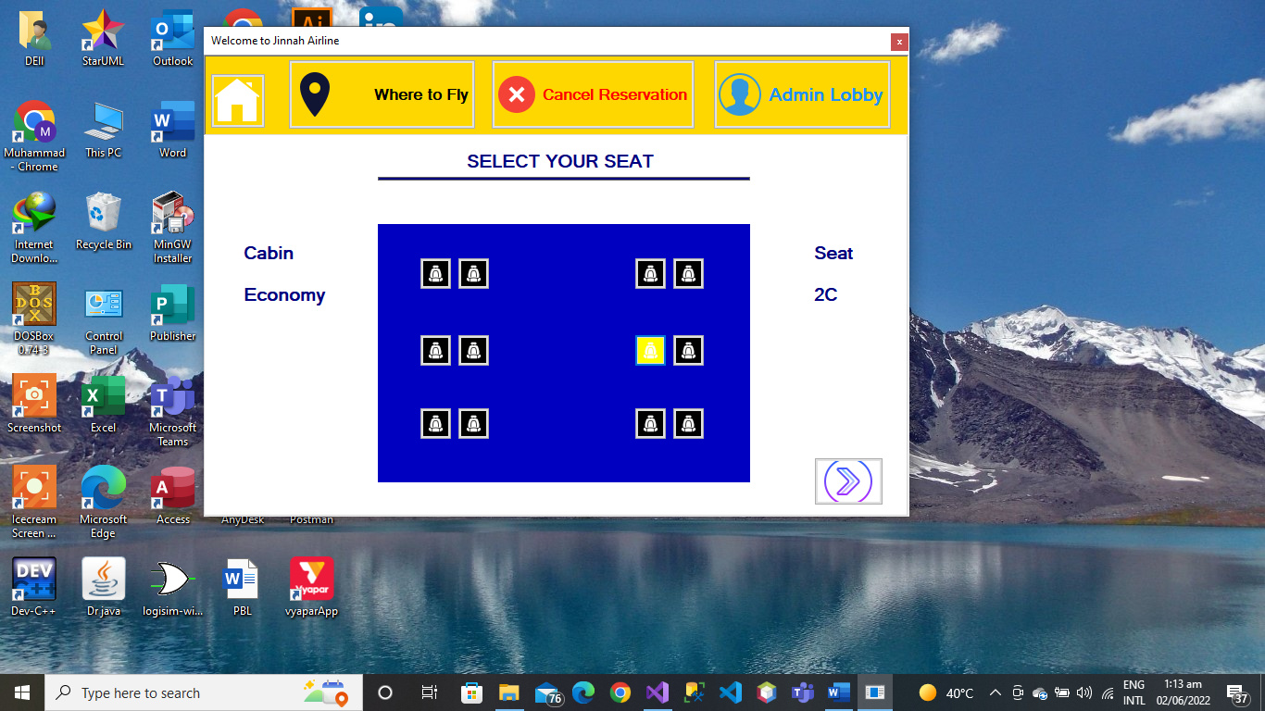

**Figure 4 Select Seat**

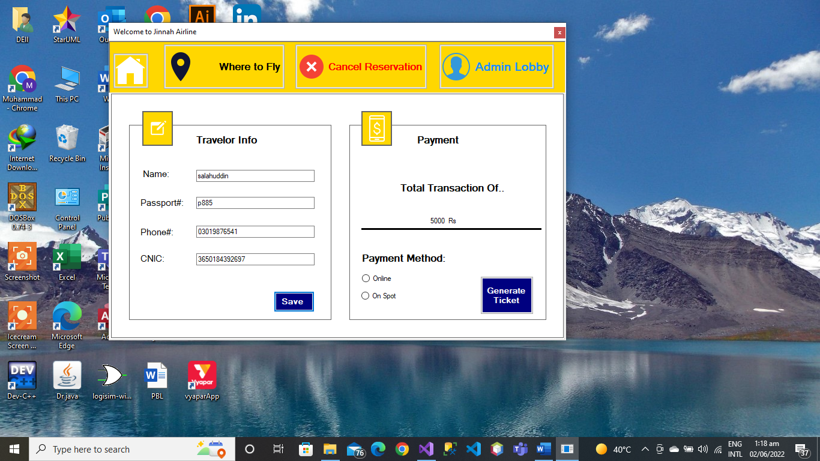

**Figure 5 Passenger Info**

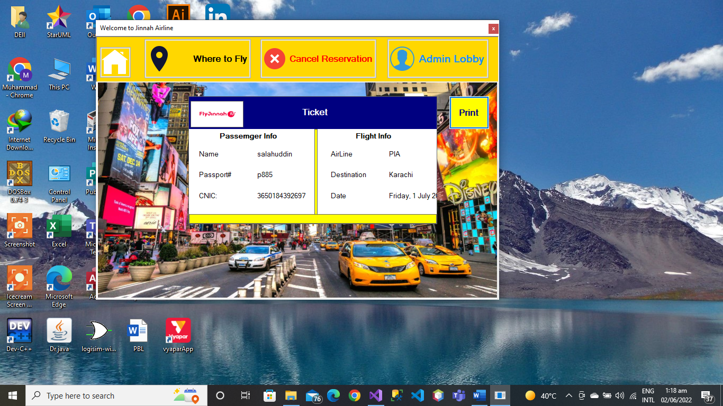

**Figure 6 Ticket**

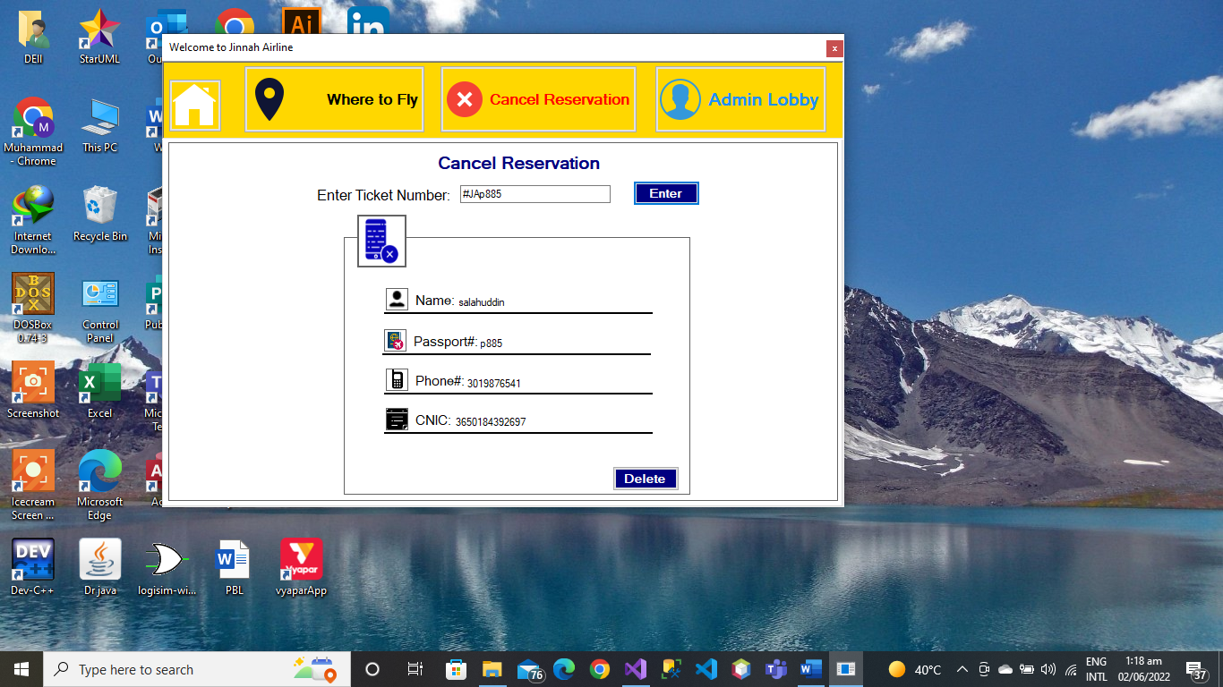

**Figure 7 cancel Reservation**

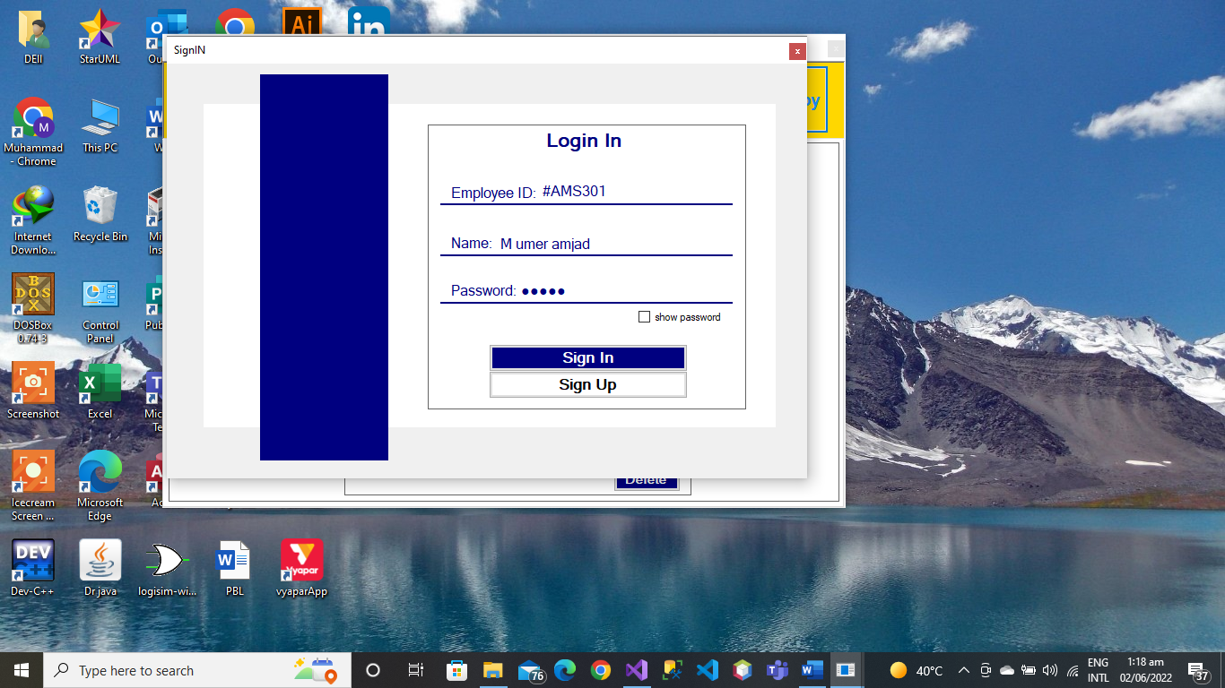

**Figure 8 Sign IN**

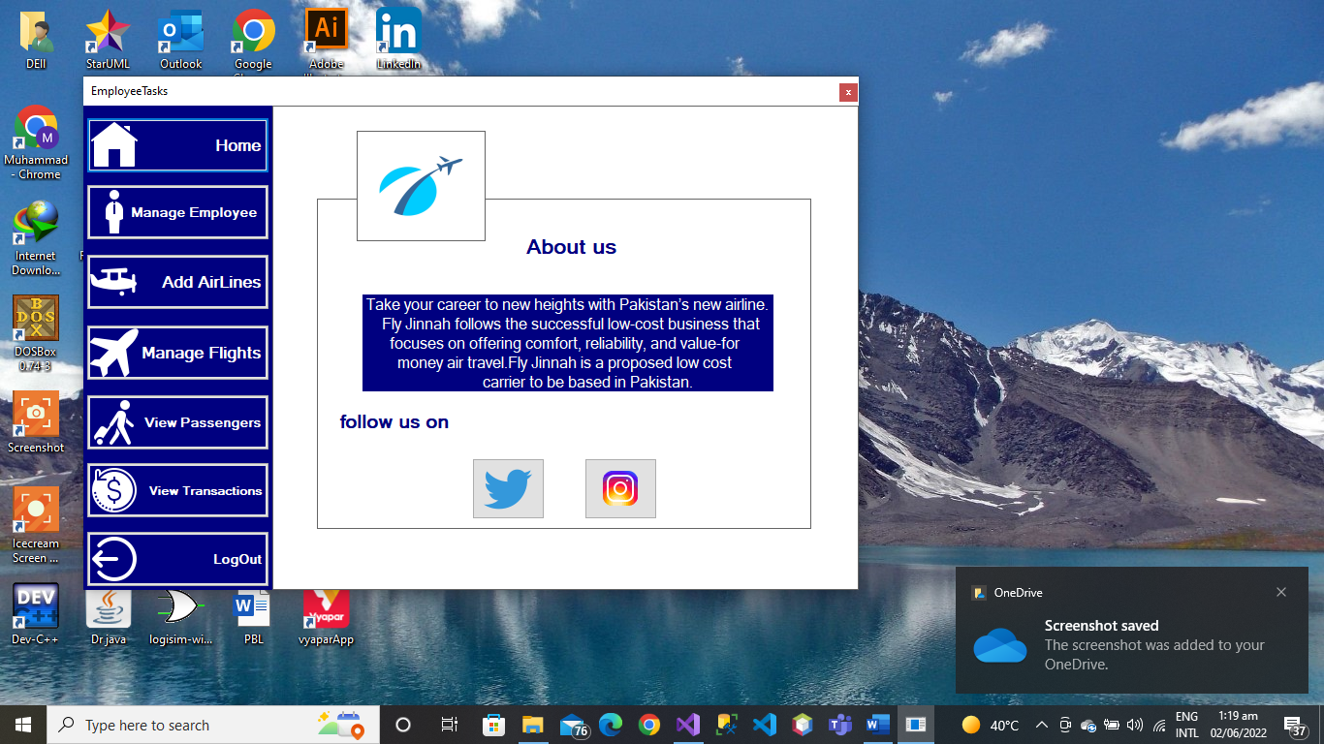

**Figure 9 Employee Tasks**

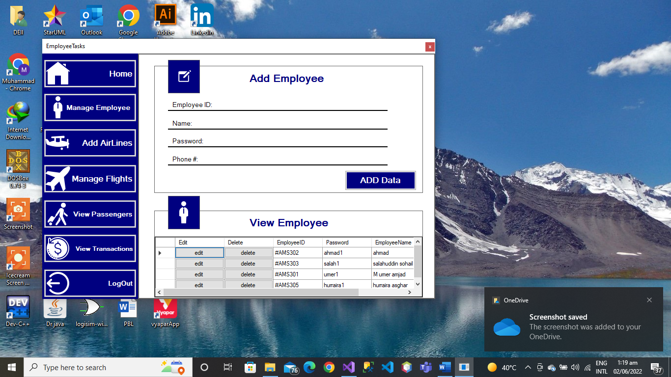

**Figure 10 AddEmployee**

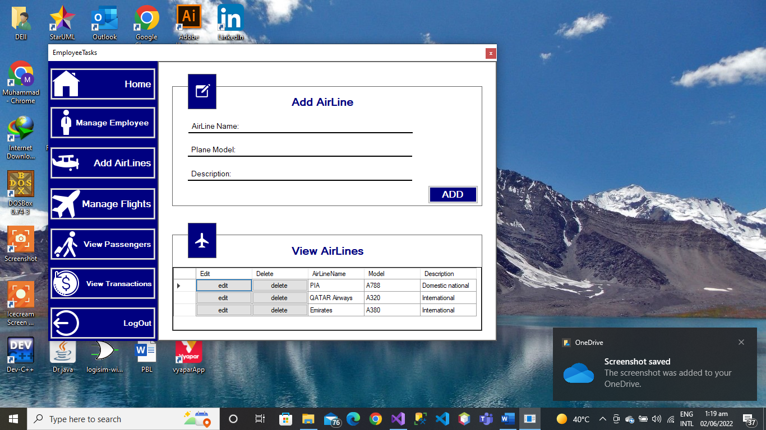

**Figure 11 Add AirLine**

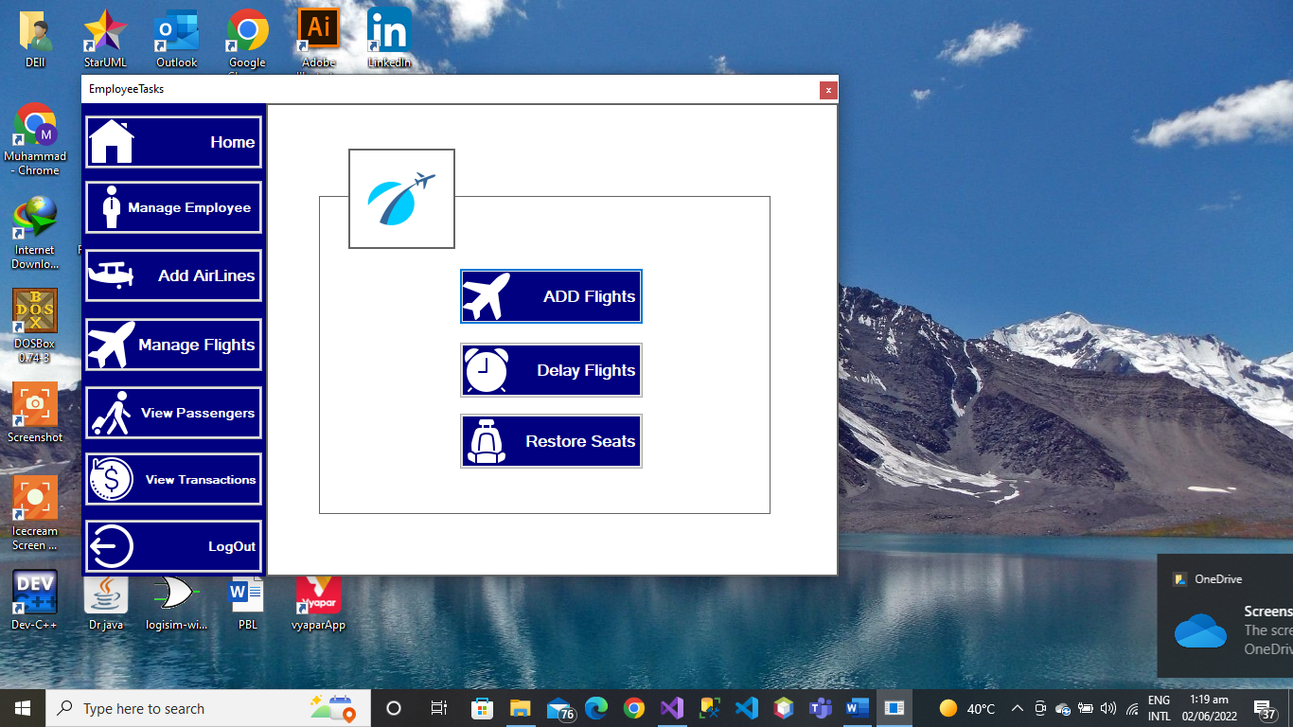

**Figure 12 View Passengers**

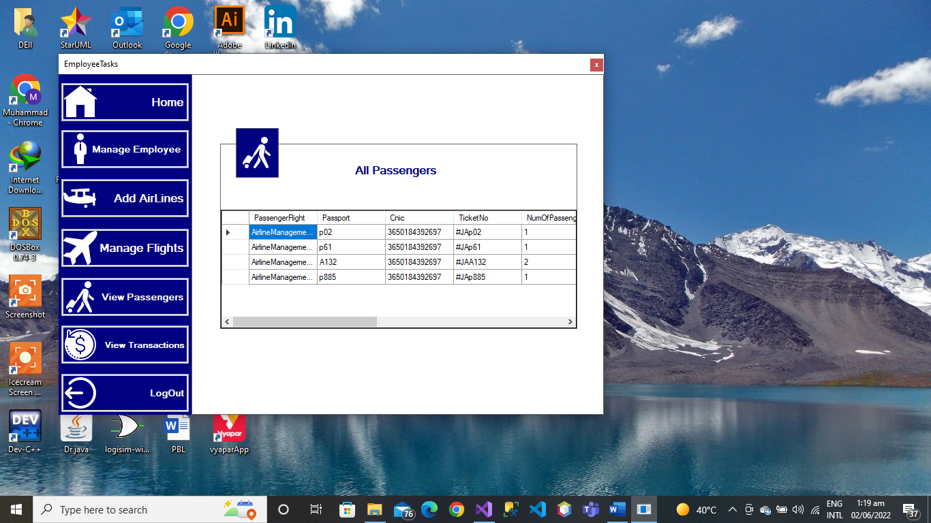

# **Code Of Classes:**

## **AddAirLineBL:**

using System;

using System.Collections.Generic;

using System.Linq;

using System.Text;

using System.Threading.Tasks;

namespace AirlineManagement

{

public class AddAirLineBL

{

private string airLineName;

private string model;

private string description;

public AddAirLineBL(string airLineName , string model , string description)

{

this.airLineName = airLineName;

this.model = model;

this.description = description;

}

public string AirLineName { get => airLineName; set => airLineName = value; }

public string Model { get => model; set => model = value; }

public string Description { get => description; set => description = value; }

}

}

## **AddFlightBL:**

using System;

using System.Collections.Generic;

using System.Linq;

using System.Text;

using System.Threading.Tasks;

namespace AirlineManagement.BL

{

public class AddFlightBL

{

private string airLine;

private string departure;

private string destination;

private string flightCode;

private string date;

private int luggage;

private int distance;

public AddFlightBL(string airLine,string departure, string destination, string flightCode, string date, int luggage, int distance)

{

this.AirLine = airLine;

this.departure = departure;

this.destination = destination;

this.flightCode = flightCode;

this.date = date;

this.luggage = luggage;

this.distance = distance;

}

public string AirLine { get => airLine; set => airLine = value; }

public string Departure { get => departure; set => departure = value; }

public string Destination { get => destination; set => destination = value; }

public string FlightCode { get => flightCode; set => flightCode = value; }

public string Date { get => date; set => date = value; }

public int Luggage { get => luggage; set => luggage = value; }

public int Distance { get => distance; set => distance = value; }

}

}

## **LoginBL:**

using System;

using System.Collections.Generic;

using System.Linq;

using System.Text;

using System.Threading.Tasks;

namespace AirlineManagement.BL

{

public class LoginBL : personBL

{

private string employeeID;

private string password;

public LoginBL(string employeeID, string employeeName, string password, long phoneNo) : base(employeeName , phoneNo)

{

this.employeeID = employeeID;

this.password = password;

}

public LoginBL(string employeeID, string employeeName, string password) : base(employeeName)

{

this.employeeID = employeeID;

this.password = password;

}

public string EmployeeID { get => employeeID; set => employeeID = value; }

public string Password { get => password; set => password = value; }

}

}

## **PassengerBL:**

using System;

using System.Collections.Generic;

using System.Linq;

using System.Text;

using System.Threading.Tasks;

namespace AirlineManagement.BL

{

class PassengerBL : personBL

{

private AddFlightBL passengerFlight;

private string passport;

private long cnic;

private string ticketNo;

private int numOfPassengers;

private string cabin;

private string seat;

private int luggage;

private double bill;

public PassengerBL(string name , long phoneNo , string passport , long cnic , string ticketNo) :base(name,phoneNo)

{

this.Passport = passport;

this.TicketNo = ticketNo;

this.Cnic = cnic;

}

public AddFlightBL PassengerFlight { get => passengerFlight; set => passengerFlight = value; }

public string Passport { get => passport; set => passport = value; }

public long Cnic { get => cnic; set => cnic = value; }

public string TicketNo { get => ticketNo; set => ticketNo = value; }

public int NumOfPassengers { get => numOfPassengers; set => numOfPassengers = value; }

public string Cabin { get => cabin; set => cabin = value; }

public string Seat { get => seat; set => seat = value; }

public int Luggage { get => luggage; set => luggage = value; }

public double Bill { get => bill; set => bill = value; }

}

}

## **PersonBL:**

using System;

using System.Collections.Generic;

using System.Linq;

using System.Text;

using System.Threading.Tasks;

namespace AirlineManagement.BL

{

public class personBL

{

protected string employeeName;

protected long phoneNo;

public string EmployeeName { get => employeeName; set => employeeName = value; }

public long PhoneNo { get => phoneNo; set => phoneNo = value; }

public personBL(string employeeName , long phoneNo)

{

this.employeeName = employeeName;

this.phoneNo = phoneNo;

}

public personBL(string employeeName)

{

this.employeeName = employeeName;

}

}

}

## AddAirLineDL:

using System;

using System.Collections.Generic;

using System.IO;

using System.Linq;

using System.Text;

using System.Threading.Tasks;

namespace AirlineManagement.DL

{

class AddAirLineDL

{

private static List<AddAirLineBL> airLineList = new List<AddAirLineBL>();

public static List<AddAirLineBL> AirLineList { get => airLineList; set => airLineList = value; }

public static void addInList(AddAirLineBL air)

{

airLineList.Add(air);

}

public static void deleteAirLine(AddAirLineBL air)

{

for (int i = 0; i < airLineList.Count; i++)

{

if (AirLineList[i].AirLineName == air.AirLineName && airLineList[i].Model == air.Model && airLineList[i].Description == air.Description)

{

airLineList.RemoveAt(i);

}

}

}

public static void editAirLine(AddAirLineBL previous, AddAirLineBL updated)

{

for (int i = 0; i < airLineList.Count; i++)

{

if (airLineList[i].AirLineName == previous.AirLineName && AirLineList[i].Model == previous.Model )

{

airLineList[i].AirLineName = updated.AirLineName;

airLineList[i].Model = updated.Model;

airLineList[i].Description = updated.Description;

}

}

}

public static void writeAllData(string path)

{

StreamWriter writer = new StreamWriter(path, false);

foreach(AddAirLineBL air in AirLineList)

{

writer.WriteLine(air.AirLineName + "," + air.Model + "," + air.Description);

}

writer.Flush();

writer.Close();

}

public static bool readData(string path)

{

if(File.Exists(path))

{

StreamReader reader = new StreamReader(path);

string record;

while((record = reader.ReadLine()) != null)

{

string[] data = record.Split(',');

string airLineName = data[0];

string model = data[1];

string description = data[2];

AddAirLineBL air = new AddAirLineBL(airLineName,model,description);

airLineList.Add(air);

}

reader.Close();

return true;

}

return false;

}

}

}

## **AddFlightDL;**

using System;

using System.Collections.Generic;

using System.IO;

using System.Linq;

using System.Text;

using System.Threading.Tasks;

using AirlineManagement.BL;

namespace AirlineManagement.DL

{

class AddFlightDL

{

private static List<AddFlightBL> flightList = new List<AddFlightBL>();

public static List<AddFlightBL> FlightList { get => flightList; set => flightList = value; }

public static void addInList(AddFlightBL flight)

{

flightList.Add(flight);

}

public static AddFlightBL returnFlight(string code)

{

foreach (AddFlightBL flights in FlightList)

{

if (flights.FlightCode == code)

{

return flights;

}

}

return null;

}

public static List<AddFlightBL> isFlightExists(string departure , string destination)

{

List<AddFlightBL> availableFlights = new List<AddFlightBL>();

foreach(AddFlightBL flights in FlightList)

{

if(flights.Departure == departure && flights.Destination == destination)

{

availableFlights.Add(flights);

}

}

return availableFlights;

}

public static void deleteFlight(AddFlightBL flight)

{

for (int i = 0; i < flightList.Count; i++)

{

if (flightList[i].Departure == flight.Departure && flightList[i].Destination == flight.Destination && flightList[i].FlightCode == flight.FlightCode)

{

flightList.RemoveAt(i);

}

}

}

public static void editFlight(AddFlightBL previous, AddFlightBL updated)

{

for (int i = 0; i < flightList.Count; i++)

{

if (flightList[i].Departure == previous.Departure && flightList[i].Destination == previous.Destination && flightList[i].FlightCode == previous.FlightCode)

{

flightList[i].Departure = updated.Departure;

flightList[i].Destination = updated.Destination;

flightList[i].FlightCode = updated.FlightCode;

flightList[i].Date = updated.Date;

flightList[i].Luggage = updated.Luggage;

flightList[i].Distance = updated.Distance;

}

}

}

public static void writeAllData(string path)

{

StreamWriter writer = new StreamWriter(path, false);

foreach (AddFlightBL flight in flightList)

{

writer.WriteLine(flight.AirLine+"+"+flight.Departure + "+" + flight.Destination + "+" + flight.FlightCode+"+"+flight.Date+"+"+flight.Luggage+"+"+flight.Distance);

}

writer.Flush();

writer.Close();

}

public static bool readData(string path)

{

if (File.Exists(path))

{

StreamReader reader = new StreamReader(path);

string record;

while ((record = reader.ReadLine()) != null)

{

string[] data = record.Split('+');

string airLine = data[0];

string departure = data[1];

string destination = data[2];

string flightCode = data[3];

string date = data[4];

int luggage = int.Parse(data[5]);

int distance = int.Parse(data[6]);

AddFlightBL flight = new AddFlightBL(airLine,departure,destination,flightCode,date,luggage,distance);

flightList.Add(flight);

}

reader.Close();

return true;

}

return false;

}

}

}

## **LoginDL:**

using System;

using System.Collections.Generic;

using System.IO;

using System.Linq;

using System.Text;

using System.Threading.Tasks;

using AirlineManagement.BL;

namespace AirlineManagement.DL

{

class LoginDL

{

private static List<LoginBL> userList = new List<LoginBL>();

public static void addInList(LoginBL u1)

{

userList.Add(u1);

}

public static List<LoginBL> UserList { get => userList; set => userList = value; }

public static LoginBL isUserExists(LoginBL user)

{

for(int i=0;i<userList.Count;i++)

{

if(userList[i].EmployeeID == user.EmployeeID && userList[i].EmployeeName == user.EmployeeName && userList[i].Password == user.Password)

{

return userList[i];

}

}

return null;

}

public static void deleteUser(LoginBL u)

{

for (int i= 0;i < userList.Count;i++)

{

if(userList[i].EmployeeID == u.EmployeeID && userList[i].EmployeeName == u.EmployeeName && userList[i].Password == u.Password)

{

userList.RemoveAt(i);

}

}

}

public static void editUser(LoginBL previous , LoginBL updated)

{

for (int i = 0; i < userList.Count; i++)

{

if (userList[i].EmployeeID == previous.EmployeeID && userList[i].EmployeeName == previous.EmployeeName && userList[i].Password == previous.Password)

{

userList[i].EmployeeID = updated.EmployeeID;

userList[i].EmployeeName = updated.EmployeeName;

userList[i].Password = updated.Password;

userList[i].PhoneNo = updated.PhoneNo;

}

}

}

public static void writeData(string path , LoginBL user)

{

StreamWriter writer = new StreamWriter(path, true);

writer.WriteLine(user.EmployeeID+","+user.EmployeeName+","+user.Password+","+user.PhoneNo);

writer.Flush();

writer.Close();

}

public static void writeALLData(string path)

{

StreamWriter writer = new StreamWriter(path, false);

foreach (LoginBL user in userList)

{

writer.WriteLine(user.EmployeeID + "," + user.EmployeeName + "," + user.Password + "," + user.PhoneNo);

}

writer.Flush();

writer.Close();

}

public static bool readData(string path)

{

if(File.Exists(path))

{

StreamReader reader = new StreamReader(path);

string record;

while((record = reader.ReadLine()) != null)

{

string[] data = record.Split(',');

string employeeID = data[0];

string employeeName = data[1];

string password = data[2];

long phoneNo = long.Parse(data[3]);

LoginBL user = new LoginBL(employeeID,employeeName,password,phoneNo);

userList.Add(user);

}

reader.Close();

return true;

}

return false;

}

}

}

## **PassengerDL:**

using System;

using System.Collections.Generic;

using System.IO;

using System.Linq;

using System.Text;

using System.Threading.Tasks;

using AirlineManagement.BL;

namespace AirlineManagement.DL

{

class PassengerDL

{

private static List<PassengerBL> passenegerList = new List<PassengerBL>();

internal static List<PassengerBL> PassenegerList { get => passenegerList; set => passenegerList = value; }

public static void addInList(PassengerBL pass)

{

passenegerList.Add(pass);

}

public static PassengerBL returnPassenger(string ticketNo)

{

foreach(PassengerBL pass in PassenegerList)

{

if(pass.TicketNo == ticketNo)

{

return pass;

}

}

return null;

}

public static void deletePassenger(string ticketNo)

{

for (int i= 0;i < PassenegerList.Count;i++)

{

if (PassenegerList[i].TicketNo == ticketNo)

{

PassenegerList.RemoveAt(i);

}

}

}

public static void writeAllData(string path)

{

StreamWriter writer = new StreamWriter(path, false);

foreach (PassengerBL pass in PassenegerList)

{

writer.WriteLine(pass.PassengerFlight.FlightCode + "+" + pass.EmployeeName + "+" + pass.Passport + "+" + pass.PhoneNo + "+" + pass.Cnic + "+" + pass.TicketNo + "+" + pass.NumOfPassengers + "+" + pass.Cabin + "+" + pass.Seat + "+" + pass.Luggage + "+" + pass.Bill);

}

writer.Flush();

writer.Close();

}

public static void writeData(string path , PassengerBL pass)

{

StreamWriter writer = new StreamWriter(path,true);

writer.WriteLine(pass.PassengerFlight.FlightCode+"+"+pass.EmployeeName+"+"+pass.Passport+"+"+pass.PhoneNo+"+"+pass.Cnic+"+"+pass.TicketNo+"+"+pass.NumOfPassengers+"+"+pass.Cabin+"+"+ pass.Seat + "+"+pass.Luggage + "+"+pass.Bill);

writer.Flush();

writer.Close();

}

public static bool readData(string path)

{

if(File.Exists(path))

{

StreamReader reader = new StreamReader(path);

string record;

while((record = reader.ReadLine()) != null)

{

string[] data = record.Split('+');

AddFlightBL flight = AddFlightDL.returnFlight(data[0]);

string name = data[1];

string passport = data[2];

long phoneNo = long.Parse(data[3]);

long cnic = long.Parse(data[4]);

string ticketNo = data[5];

int numOfPassenger = int.Parse(data[6]);

string cabin = data[7];

string seat = data[8];

int luggage = int.Parse(data[9]);

double bill = double.Parse(data[10]);

PassengerBL pass = new PassengerBL(name, phoneNo, passport, cnic, ticketNo);

pass.PassengerFlight = flight;

pass.NumOfPassengers = numOfPassenger;

pass.Cabin = cabin;

pass.Seat = seat;

pass.Luggage = luggage;

pass.Bill = bill;

passenegerList.Add(pass);

}

reader.Close();

return true;

}

return false;

}

}

}